Lab 06 Tasks

Code 01:
#include <iostream>
using namespace std;

class WeatherStats{
public:
static double calculateAverageTemperature(const double temps[], int size)
{
if (size <= 0) return 0;

double sum = 0;

for (int i = 0; i < size; i++)
{
sum += temps[i];
}

return sum / size;
}
};

class ExtendedWeather : public WeatherStats{
public:
double getTemperatureFluctuation(const double temps[], int size) const
{
if (size <= 0) return 0;

double highest = temps[0];
double lowest = temps[0];

for (int i = 1; i < size; i++)
{
if (temps[i] > highest)
highest = temps[i];

if (temps[i] < lowest)
lowest = temps[i];
}

return highest - lowest;
}
};

int main()
{
int size = 5, i;
double temperatures[size];
double avg;
double fluctuation;
ExtendedWeather ew;

for(i = 0; i<size; i++){
cout << "Temperature at Day " << i << ": " << endl;
cin >> temperatures[i];
cin.ignore();
}

avg = WeatherStats::calculateAverageTemperature(temperatures, size);
cout << "Average Temperature: " << avg << endl;

fluctuation = ew.getTemperatureFluctuation(temperatures, size);
cout << "Temperature Fluctuation: " << fluctuation << endl;

return 0;
}

Output:
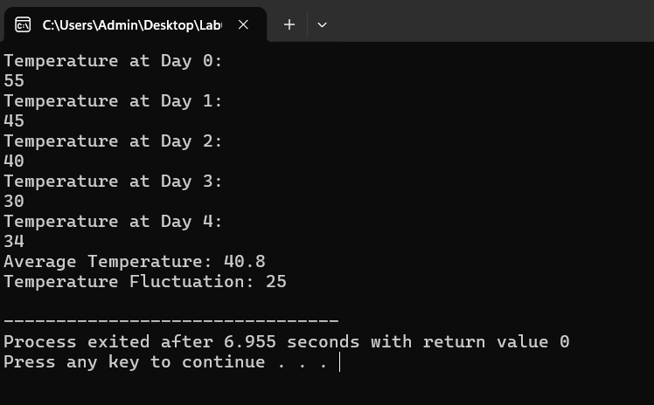

Code 02:
#include <iostream>
#include <string>
using namespace std;

class Message {
private:
string text;

public:
void setText(string t) {
text = t;
}

string getText() const {
return text;
}

virtual string toString() const {
return text;
}
};

class SMS : public Message {
private:
string recipientContactNo;

public:
void setRecipientContactNo(string number) {
recipientContactNo = number;
}

string getRecipientContactNo() const {
return recipientContactNo;
}

string toString() const override {
return "Contact No: " + recipientContactNo +
" | Message: " + getText();
}
};

class Email : public Message {
private:
string sender;
string receiver;
string subject;

public:
void setSender(string s) {
sender = s;
}

void setReceiver(string r) {
receiver = r;
}

void setSubject(string s) {
subject = s;
}

string getSender() const {
return sender;
}

string getReceiver() const {
return receiver;
}

string getSubject() const {
return subject;
}

string toString() const override {
return "Sender: " + sender +
" | Receiver: " + receiver +
" | Subject: " + subject +
" | Message: " + getText();
}
};

bool ContainsKeyword(const Message& messageObject, const string& keyword) {
string text = messageObject.getText();
return text.find(keyword) != string::npos;
}

string encodeMessage(string message) {

for(int i = 0; i < message.length(); i++) {

if(message[i] >= 'A' && message[i] <= 'Y')
message[i]++;

else if(message[i] == 'Z')
message[i] = 'A';

else if(message[i] >= 'a' && message[i] <= 'y')
message[i]++;

else if(message[i] == 'z')
message[i] = 'a';
}

return message;
}

int main() {

SMS sms1;
sms1.setRecipientContactNo("03001234567");
sms1.setText("Hello this is Moazam");

cout << "SMS Details:\n";
cout << sms1.toString() << endl;

Email email1;
email1.setSender("moazam@gmail.com");
email1.setReceiver("friend@gmail.com");
email1.setSubject("Meeting");
email1.setText("This is Java");

cout << "\nEmail Details:\n";
cout << email1.toString() << endl;

string keyword = "Java";
if(ContainsKeyword(email1, keyword))
cout << "\nKeyword found in email message.\n";
else
cout << "\nKeyword not found.\n";

string encoded = encodeMessage(email1.getText());

cout << "\nOriginal Message: " << email1.getText() << endl;
cout << "Encoded Message: " << encoded << endl;

return 0;
}

Output:
